**EQUITY**

**RESEARCH**

**REPORT**

**SHREE CEMENT LIMITED**

**BSE: 500387 | NSE: SHREECEM |ISIN: INE070A01015 | SECTOR: Building Materials (Cement)**

Shree Cement was incorporated in 1979 by Benu Gopal Bangur and began its operations with a 0.6 MTPA integrated cement plant in Beawar, Rajasthan. The company went public in 1984 with a listing on the Bombay Stock Exchange. Over the next three decades, it steadily scaled operations, reaching 10 MTPA by 2010. From these modest beginnings, Shree Cement has emerged as India’s third-largest cement producer, behind only UltraTech and Ambuja Cements. In recognition of its consistent growth and strong market presence, the company became part of the prestigious Nifty 50 index in March 2020.

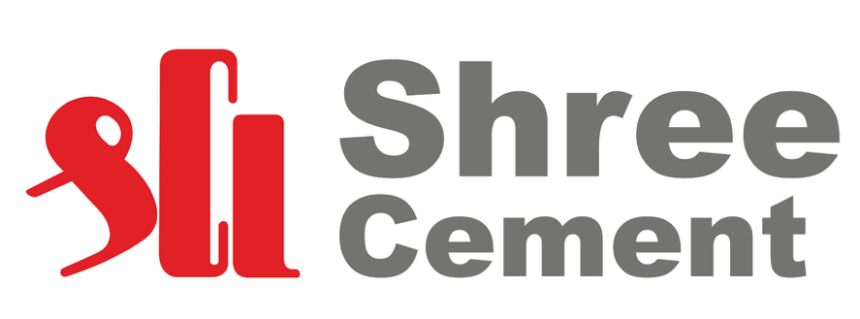

Today, it operates 7 integrated plants including one in the UAE and 13 grinding units, with a cement capacity of 62.8 MTPA. With a clear roadmap to reach 80 MTPA by 2028, Shree Cement continues its journey of innovation-led, sustainable growth. In 2024, Shree Cement underwent a brand transformation, unifying its identity under the Bangur name.

Shree Cement reinforced its strategic emphasis on premiumisation and brand-driven growth during Q1FY26 with the launch of Bangur Marble, a high-performance Portland Slag Cement (PSC), in Bihar, Jharkhand, and West Bengal. This addition further bolstered its premium portfolio, which includes Bangur Magna, Roofon Plus, Rockstrong, and Powermax. As a result, the share of premium products in trade sales rose to 17.7% in Q1FY26, up from 15.6% in Q4FY25, reflecting growing consumer preference for value-added offerings.

Its UAE operations continued to perform strongly, with revenue growing 19% year-on-year to AED 181.19 million. Operating profit (EBITDA) surged 397% to AED 44.86 million from AED 9.02 million in the same quarter last year, driven by robust demand and enhanced efficiency. Capitalising on this momentum, Shree Cement’s UAE subsidiary, Union Cement Company (UCC), announced a 3.0 MTPA capacity expansion with an investment of AED 110 million.

Shree Cement reinforced its sustainability leadership with top-tier ESG ratings and inclusion in the S&P Global Sustainability Yearbook. In Q1FY26, green electricity made up 65.65% of total power consumption—one of the highest in India’s cement sector—with green power capacity reaching 586 MW out of 1,085 MW. The company used 0.15 lakh tonnes of agro waste, generating 51 billion kCal of energy and cutting 0.20 lakh tonnes of CO₂ emissions. In the NCR, it sourced 2,877 tonnes of stubble, and also consumed 0.53 lakh tonnes of hazardous waste, replacing 32 billion kCal of fossil fuel-based energy, supporting its decarbonisation efforts.

Shree Cement showcased strong operational growth, expanded its premium portfolio, advanced its UAE business, and reaffirmed its leadership in green energy and sustainable practices.

**FINANCIAL INFORMATION**

|  |  |  |
| --- | --- | --- |
| **INR MILLIONS** | **FY25** | **FY24** |
| Total Assets | 28,492 | 27,953 |
| EBIT | 927 | 2,619 |
| PAT | 1,124 | 2,396 |
| Total Revenue | 19,283 | 20,404 |

*Source: Company Annual Reports*

On a standalone basis, Shree Cement reported net revenue of ₹4,948 crore in Q1FY26, up 2% from ₹4,835 crore in Q1FY25. EBITDA rose 34% to ₹1,229 crore from ₹916 crore, while profit after tax surged 95% to ₹619 crore compared to ₹318 crore last year. Cash profit stood at ₹1,161 crore, marking a 24% increase over ₹938 crore in the corresponding quarter of the previous year.

EPS fell to ₹311.18 in FY25 from ₹663.98 in FY24, signalling weaker earnings performance. Despite elevated capital spending, the dividend in FY25 was ₹110 per share, only marginally higher than ₹105 per share in FY24, reflecting muted shareholder returns.

Overall, while short-term quarterly performance shows strong recovery momentum in FY26, the FY25 annual results point to a challenging year marked by earnings deterioration and subdued returns.

|  |  |
| --- | --- |
| **Price to Book Value** | 5.08 |
| **Dividend Yield** | 0.36 |
| **Return on Assets (ROA)** | 3.97 |
| **Return on Equity (ROE)** | 5.29 |
| **Return on Employed Capital (ROCE)** | 6.71 |

*Source: Company Financial Report*

**SHAREHOLDING PATTERN**

*Source: Company Shareholding Report*

|  |  |
| --- | --- |
| **Majority shareholders** | Promoters |
| **FIls** | 9.71% |
| **Mutual Fund** | 10.23% |
| **Promoters with Highest Holdings** | 24.90% |
| **Pledged Promoter Holding** | None |
| **Largest Single Shareholder** | None |
| **Individual Investors holdings** | 12.42% |

**SHAREHOLDING COMPARE (% Holding)**

|  |  |  |  |
| --- | --- | --- | --- |
| **Majority shareholders** | **62.55%** | **62.55%** | **-** |
| **FIIs** | **9.71%** | **12.48%** | **-2.77%** |
| **Mutual Fund** | **10.23%** | **7.55%** | **+2.68%** |
| **Insurance Companies** | **4.71%** | **4.36%** | **+0.35%** |
| **Non institutional Investors** | **12.42%** | **12.63%** | **-0.21%** |
| **Other DIIs** | **0.58%** | **0.43%** | **+0.15%** |

*Source: Company Shareholding Report*

**COMPARE VALUATION WITH PEERS**

|  |  |  |  |
| --- | --- | --- | --- |
| **Company** | **P/E** | **EV/EBITDA** | **PEG RATIO** |
| **Ultratech** | 51.7 | 30.4 | -9.70 |
| **Ambuja** | 33.1 | 24.3 | 2.48 |
| **JK** | 59.3 | 27.0 | 13.6 |
| **Dalmia** | 45.7 | 19.4 | -22.4 |
| **ACC** | 14. | 10.8 | 2.18 |
| **Ramco** | 103.9 | 26.3 | -5.23 |

*Source: Company Financial Report*

Shree Cement is steadily expanding its integrated capacity and market presence through disciplined execution and a focus on premiumisation. In FY25, it commissioned key units at Etah (Uttar Pradesh) and Baloda Bazar (Chhattisgarh), raising total cement capacity to 62.8 MTPA. The clinker unit at Nawalgarh was also upgraded to 4.5 MTPA, strengthening operational efficiency and deepening its footprint in high-demand Northern and Eastern markets.

Further capacity additions are underway, with 3.0 MTPA integrated plants at Jaitaran (Rajasthan) and Kodla (Karnataka) progressing as per schedule. On completion, total cement capacity will reach 68.8 MTPA.

Simultaneously, the company is scaling up its Ready-Mix Concrete (RMC) segment—from 15 plants at the start of FY25 to 21 currently—with a target of 50 by year-end, enhancing its value chain integration.

With a robust net cash position of ₹5,400 crore as of March 2025, Shree Cement is well-positioned to fund its ₹3,000 crore FY26 capex plan while maintaining strong financial discipline.

**PRICE ACTION**

|  |  |
| --- | --- |
| **Parameters** | **Range** |
| Volume Traded | 91,073 |
| Current Price | 30590 |
| Face Value | 10.0 |
| Previous Value | 30645 |
| Open Price | 30,725 |
| Today low/high | 30,120/31,110 |
| 52-week low/high | 23,500/32,490 |

*Source: Bombay Stock Exchange*

India’s resilient macroeconomic backdrop—anchored by 6.5% real GDP growth in FY25 and a similar outlook for FY26—continues to support infrastructure and housing, creating a solid base for cement demand. While cement consumption grew ~5% in FY25, industry growth is expected to accelerate to 6.5–7.5% in FY26, driven by government capex, real estate activity, and rural housing.

With over 90% of its revenue from India, Shree Cement is strategically positioned to benefit from these trends. Its expanding 62.8 MTPA capacity, well-balanced mix of integrated and grinding units, and disciplined execution enhance its readiness to tap this upcycle. Focused on cost efficiency and market consolidation, the company is poised to capture share and deliver long-term value through operational strength and sector-aligned growth.

*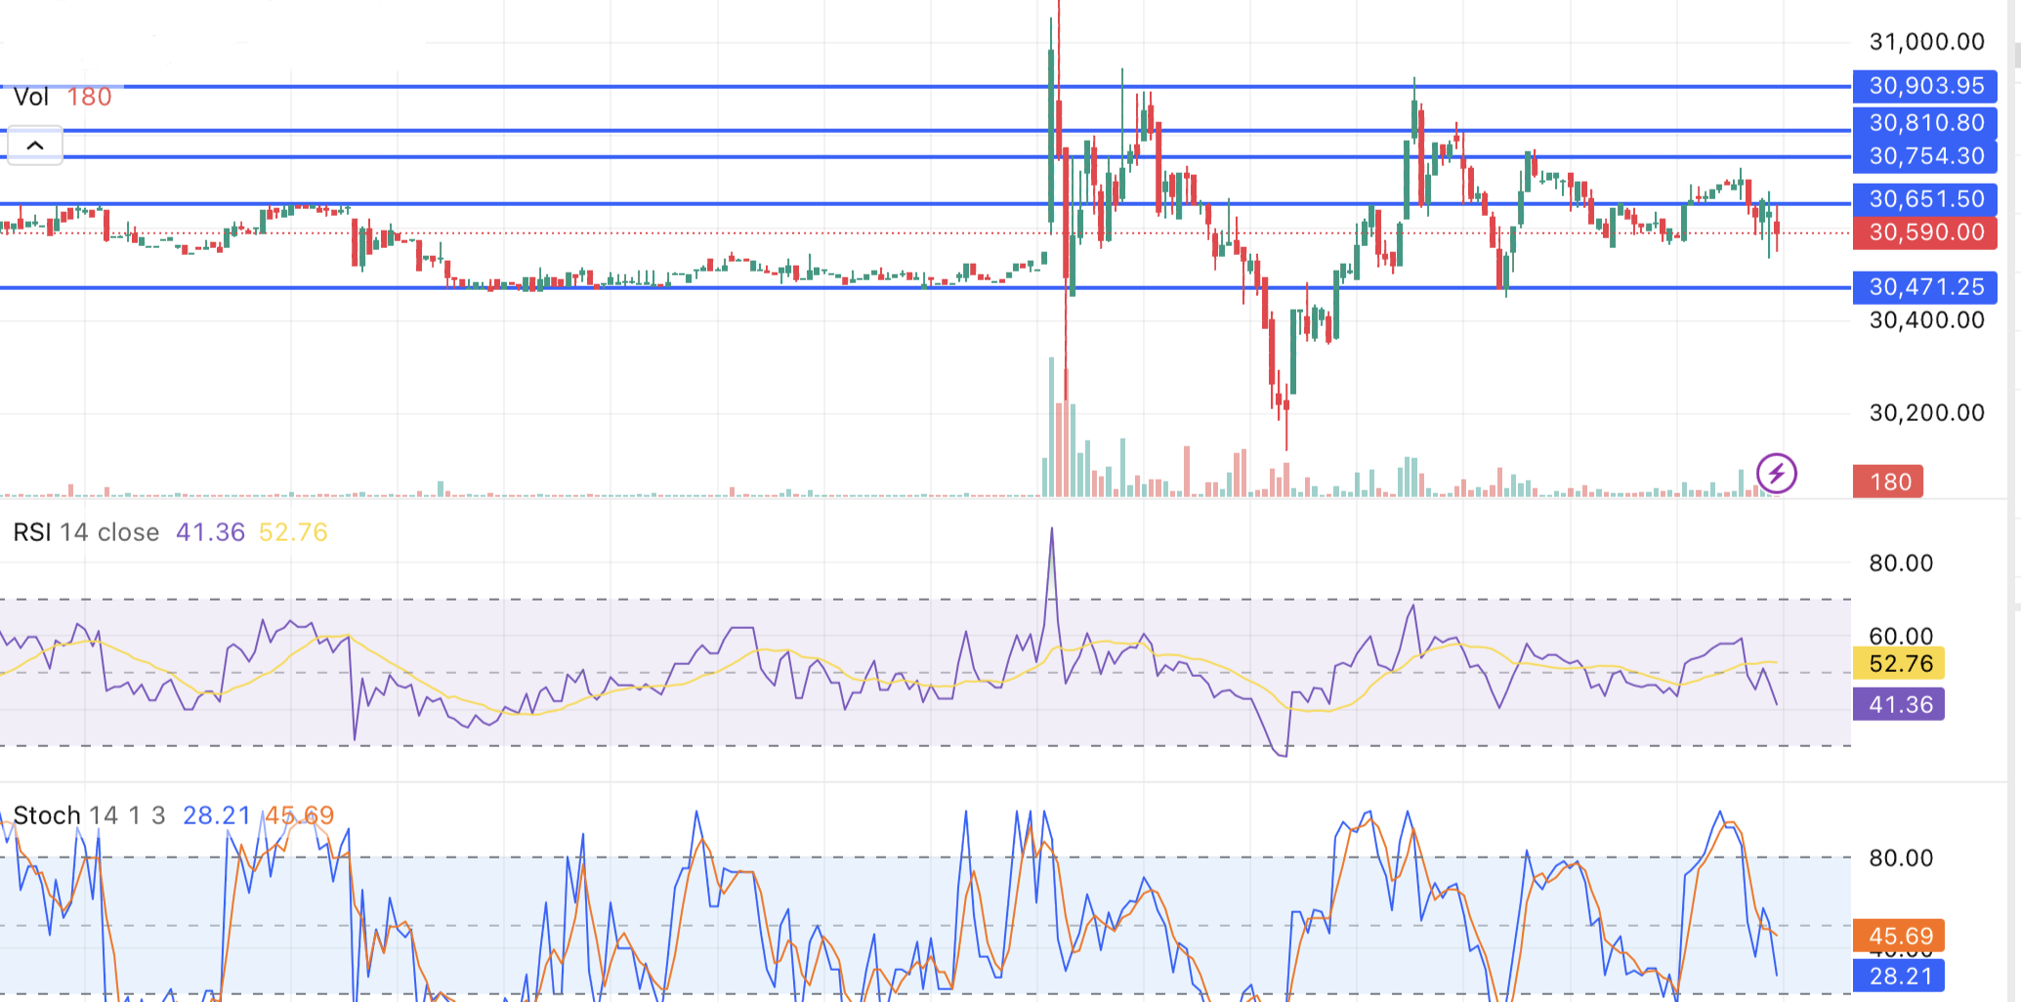Source: National Stock Exchange*

Shree Cement’s FY2025 financials signal rising stress across key metrics. Revenue declined 5.5% YoY to ₹19,283 crore, down from ₹20,404 crore, amid weak demand and limited pricing power. EBITDA contracted 12.9% to ₹3,934 crore, pressured by elevated input costs and reduced operating leverage. The consistent dip across topline and margins underscores a challenging macro backdrop and weak near-term earnings visibility.

The stock closed at ₹30,590 on August 04, 2025, down 0.20%, slipping below key moving averages. RSI (41.36) and Stochastic (%K at 28.21, %D at 45.69) reflect weakening momentum near oversold levels. While a rebound is possible if ₹30,471–₹30,650 support holds, a move above ₹30,903.95 is needed to reverse sentiment.

Intraday action remained choppy, with price hovering around the 50/100/200 DMAs (₹30,659–₹30,565). Repeated failures to sustain above the 50-DMA and tests of the 200-DMA indicate fragile momentum. A breakdown below ₹30,565 could trigger further downside, keeping the intraday bias cautiously bearish.

**Disclaimer** *The views, analysis, and content presented here are for informational purposes only and do not constitute financial, investment, tax, or legal advice. They do not take into account your individual objectives, financial situation, or specific needs. Before acting on any information provided, you should carefully consider its suitability in light of your personal circumstances and consult with a qualified financial adviser, stockbroker, or legal/tax professional as appropriate.*

*Not all investments or strategies discussed may be suitable for every investor. The information shared is based on sources believed to be reliable and accurate at the time of writing; however, no guarantee is given as to its completeness or correctness. You are encouraged to conduct your own due diligence before making any investment decisions.*

*To the fullest extent permitted by law, the author disclaims any and all liability for any loss or damage arising from reliance on the information provided, including indirect or consequential losses, or data-related damages. Where such exclusions are not permitted by law, liability is limited to the provision of equivalent services as allowed under applicable legislation.*

*All information is subject to change without notice.*